**Use Linux to view the MAC address table of a switch (if using a Linux-based network switch). Use the bridge or ip link commands to inspect the MAC table and demonstrate a basic switch's operation.**

**Steps I Followed:**

* Created a bridge interface (br0) to act as a switch.
* Enabled the bridge and interface to allow network traffic flow.
* Checked available network interfaces on the system.
* Verified that the Linux system was acting as a switch.
* Added a physical interface to the bridge to simulate switch ports.
* Inspected the MAC address table using bridge fdb show to check learned MAC addresses.

**Creating bridge interface**



**Network Interfaces**

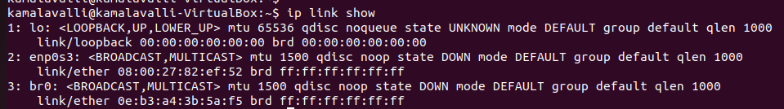

**Linux system is acting as switch:**



**Adding Physical Interface:**



**Mac Address Table**

